Executive summary



Image Generation

Executive summary

# Overview

leonardo AI tends to produce more realistic and detailed images compared to DALL·E, especially when it comes to people and natural lighting. While DALL·E often creates more artistic or stylized visuals, Leonardo focuses on lifelike textures and cinematic vibes. For scenes like a girl holding coffee in Italy, Leonardo can capture the immersive, grand background with natural sunlight and fine details better. If you want, prompts can be customized to highlight these strengths and get exactly the look you want.

|  |  | Dall EDall E have some cool features  * 1. Creative and imaginative outputs   2. Strong at abstract and artistic styles   3. User-friendly with versatile prompt handling |
| --- | --- | --- |

| Leonardo AILeonardo is more realistic than Dall E  * 1. Highly realistic and detailed images   2. Excellent at natural lighting and textures   3. Great for lifelike human figures and environments |  |  |
| --- | --- | --- |

## **Task 1: Comparative Research — DALL·E vs Leonardo AI**

### **1. Image Quality**

* **DALL·E:** Produces high-quality images with vibrant colors and good detail. It can sometimes be more artistic or stylized depending on the prompt.
* **Leonardo AI:** Known for extremely realistic and detailed images, especially with human figures, textures, and natural lighting.

### **2. Prompt Accuracy**

* **DALL·E:** Generally interprets prompts very well, especially descriptive ones, creating images that closely match the text.
* **Leonardo AI:** Also very good at prompt accuracy, with an emphasis on realism. It interprets complex prompts and renders lifelike visuals.

### **3. Style Flexibility**

* **DALL·E:** Versatile in style, ranging from photorealistic to surreal or artistic. Good for abstract, imaginative outputs.
* **Leonardo AI:** Focuses more on photorealism and cinematic styles but can handle a variety of naturalistic artistic styles well.

### **4. Usability**

* **DALL·E:** Easy to use, available via ChatGPT and OpenAI platforms, with simple prompt input and user-friendly interface.
* **Leonardo AI:** Also user-friendly but sometimes requires specific prompt engineering to get the best realism; available through its own platform.

### **5. Licensing & Terms**

* **DALL·E:** Allows commercial use of generated images under OpenAI’s policies, with some restrictions on sensitive content.
* **Leonardo AI:** Offers commercial rights for images generated, with user ownership depending on subscription plans and terms.

**Sunset Jazz Festival in Venice** Experience an unforgettable evening of soulful jazz music by the enchanting Venetian canals. As the sun sets, warm hues of orange and pink fill the sky, reflecting off the shimmering waters where gondolas gently glide by. The festival blends vibrant live performances with a romantic, magical atmosphere, illuminated by glowing fairy lights and floating lanterns. Join us for a night of music, culture, and beauty in one of the world’s most picturesque cities.

Dall E



Leonardo AI

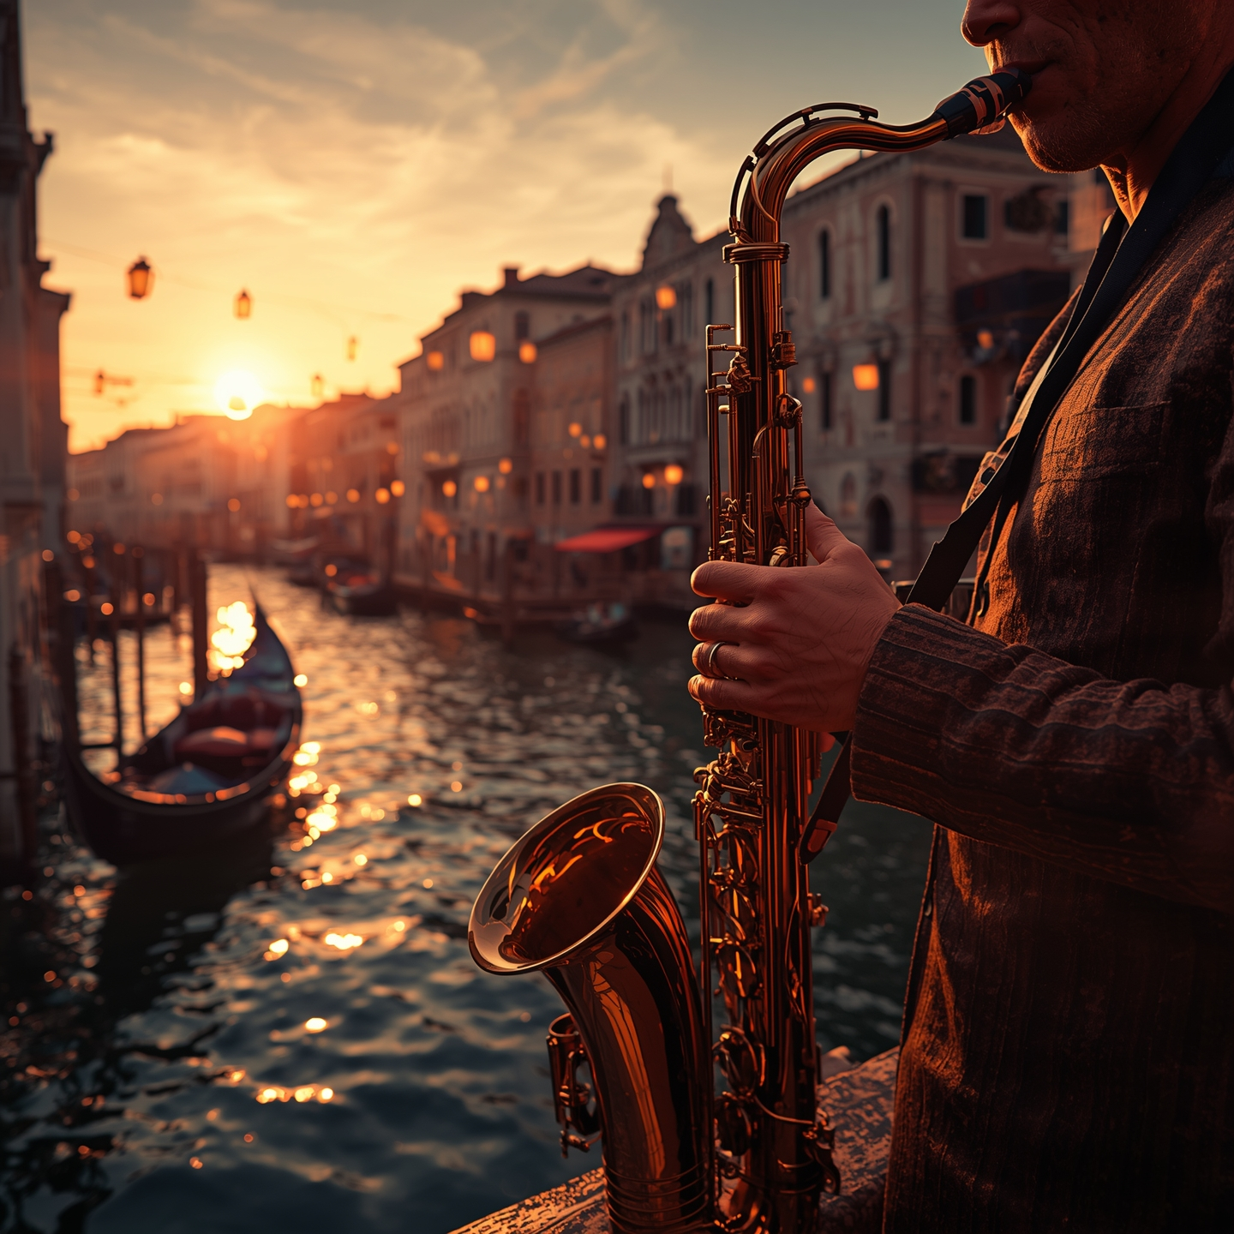

Introduction & recommendations

# Introduction

## Background

### Provide context for the project

Provide an overview of the project, including its origins, client, goals, and impact. Describe the leading company or individual, highlighting relevant qualifications and past successes. This section can include more depth and context for the reader.

## Objectives

### State the case study goals and objectives

* 1. Objective 1
  2. Objective 2
  3. Objective 3

## Problem

### Outline what motivated the project

Share the primary problem, challenge, or opportunity that the project aimed to address. Clearly articulate the issue or need that motivated the project. The length of this section is based on the complexity of the problems addressed in the project.

# Recommendations

### Outline the solutions, strategies, or recommendations proposed to address the problem or achieve the project's objectives

1. Recommendation 1
2. Recommendation 2
3. Recommendation 3

## Impact of recommendation

|  | SOLUTION | EFFECTIVENESS | IMPACT | NOTES |
| --- | --- | --- | --- | --- |
|  | Recommendation 1 | Highly effective | Add impact notes | Add additional context |
|  | Recommendation 2 | Ineffective | Add impact notes | Add additional context |
|  | Recommendation 3 | Marginally effective | Add impact notes | Add additional context |

Analysis

# Analysis



## Research methods

### Note the methods used to gather data for the case study

Many case studies use a mixed-methods approach that combines qualitative and quantitative data collection techniques. The level of detail in this section depends on the audience for the case study.

## Approaches used

### Outline the specific approaches or frameworks used

Framework could include theoretical models, industry standards, or best practices. Theoretical models help people understand the situation. Industry standards and best practices can help evaluate performance, gain insights, and identify areas to improve.

## Relevant facts and information

### Present key facts

* 1. In a few bullet points, present key facts, figures, and information that surfaced during analysis, such as: project specifications, timelines, budgets, or other quantitative data
  2. Describe how those facts relate to the problem statement
  3. Include specific sources and data points where possible

Conclusion

# Conclusion



## Summary of findings

### Summarize the main findings or conclusions of the case study

This should be a more comprehensive summary, taking the whole project into consideration and incorporating key findings from the entire document. Use multiple paragraphs if necessary.

## Implications of the study

### Describe the impact of the completed study

Focus on real-world impact, concrete outcomes and how they addressed the project’s goals. Evaluate outcomes using both objective data and subjective feedback. Draw well-supported conclusions based on analysis and interpretation of relevant information.

#### “Feature a quote from the case study. It should be a key takeaway or learning that you want audiences to remember.”

If your implications explanation is lengthy, you can break it up with a quote to help communicate a key takeaway.

References

# References

### Check what reference style your organization typically uses. Below is an example of the format for citing references called APA. Other common formats include MLA and Chicago Style.

##### Examples:

Lastname, A. (Year). *Book Title*. Publisher. DOI

Lastname, A., Lastname, B., & Lastname, C. (Year). Article title. *Journal Title, Volume#*(Issue#), Page(s)#. DOI

Lastname, A. (Year, Month Day). *Title*. Site Name. URL

## Supplementary materials

|  | FILE | NOTES |
| --- | --- | --- |
|  | File | Files might include surveys, questionnaires, or data tables |
|  | File | Add file notes |
|  | File | Add file notes |